
Tribhuvan University
Institute of Science & Technology
Samriddhi College

A
Lab Report
on
Advanced Java Programming

Submitted by:
Ravi Shankar Sah (79011167)

Submitted to:
Department of Computer Science & Information Technology
Samriddhi College
Lokanthali-1, Bhaktapur

March , 2025

List Of Programs:
S.No. | Name of the Program | Page No. | Date | Sign
1. | Write a GUI program using components to find sum and difference of two numbers.Use two text fields for giving input and a label for output. The program should display sum if user presses mouse and difference if user release mouse.
2. | Write a Program using swing components to add two digit. Use text fields for inputs and output. Your program should display the result when the user presses a button.
3. | Write a program to Create a Form Below using Swing and perform Add, Subtract, Multiply and Divide as user click button with selected option.
4. | Write a GUI program using components to find sum and difference of two numbers.Use two text fields for giving input and a label for output. The program should display sum if user presses mouse and difference if user release mouse using adapter class.
5. | Create a Simple Login Form using GridLayout in Java.
6. | Create a Simple Login Form using GridBagLayout in Java.
7. | Write a program that divides the frame into five regions by using border layout and then add panels in the east, north and center region. Finally add some descriptive label in the north panel, buttons with icon in the east panel and a sample form in the center panel. You can further subdivide the center panel, if necessary. Prepare a program with three text boxes First Number, Second Number, and Result and four buttons add, subtract, multiply and divide. Handle the events to perform the required operation and display results.
8. | Design a form with three buttons with captions “RED,” “BLUE,” and “GREEN,” respectively. Then write a program to handle the event such that when the user clicks the button, the color of that button will be the same as its caption.  Design a form with three buttons with captions “RED,” “BLUE,” and “GREEN,” respectively. Then write a program to handle the event such that when the user clicks the button, the color of Form background will be the same as its caption.
9. | Write a Java program using Swing that demonstrates the use of different layout managers (FlowLayout, GridLayout, and BorderLayout).  - Divide the main frame into three panels using BorderLayout:  - North Panel: Use FlowLayout to arrange three labels (Name, Roll No, Class) in a single row.  - Center Panel: Use GridLayout (3x2) to create a simple login form with two text fields (Username, Password), a JCheckBox (“Remember Me”), and a JButton (“Login”).  - South Panel: Use FlowLayout to add two buttons (Reset and Exit).  - Handle events so that:  - When Login is pressed, display the entered username in a message dialog.  - When Reset is pressed, clear the text fields.  - When Exit is pressed, close the program.
10. | Design a form with three buttons with captions “Circle,” “Square,” and “Triangle.”  - When the user clicks the “Circle” button, draw a red circle in the center of the frame.  - When the user clicks the “Square” button, draw a blue square in the center of the frame.  - When the user clicks the “Triangle” button, draw a green triangle in the center of the frame.
11. | Design a Swing application that contains three radio buttons labeled "Red", "Green", and "Blue". When the user selects a radio button, the background color of the window should change to the selected color. Implement event handling using an ItemListener.
12. | Write a Java Swing program to create a toolbar with three buttons. Each button should display an icon (New, Login, and Logout). Place the toolbar at the top of the window using a suitable layout. When a button is clicked, display a message dialog showing the name of the action (e.g., “New File Created”, “Login Successful”, “Logged Out”).
13 | Write a java program to inset 5 student records and display record in name ascending order, given table student(Id,Name,Gender,Address) using JDBC. | 2025-3-11
14. | Write a java program update salary by 15% wholes salary less than 20000 from given table student(Id,Name,Salary,Gender) using JDBC | 2025-3-11
15. | Write a Java program using JDBC to connect to a MySQL database, create a table named tblStudent with columns id, name, and email, and insert a record into the table using a prepared statement. | 2025-3-11
16. | Write a Java program using JDBC to connect to a MySQL database and display employee details from the emp table. The program should demonstrate how to move through the result set using navigation methods such as first(), last(), previous(), and next(), and print the corresponding employee records on the console. | 2025-3-11
17. | Write a Java program using JDBC to connect to a MySQL database and retrieve an employee record from the emp table based on a given ID using a prepared statement. The program should use an updatable ResultSet to modify the employee’s name and update the record in the database.
18. | Write a program to demonstrate servlet life cycle.
19. | Write a Java program to store “Samriddhi College” String value in session and retrieve from session using Servlet.
20. | Write a Java program to store Username and Password from two input field in cookies and retrieve value from cookies using Servlet.
21. | Write a Java program to store Username and Password from two input field in cookies and retrieve value from cookies using JSP.
22. | Write a program to a JSP web form to take input of a student and submit it to second JSP file which may simply print the values of form submission.
23. | Write a program to a JSP web form to take principle,Time and Rate as input from textfield and calculate it and display Simple interest in second JSP.
24. | Write a java program to add two digit using RMI
25.
26.

Lab 1 : Write a GUI program using components to find sum and difference of two numbers.Use two text fields for giving input and a label for output. The program should display sum if user presses mouse and difference if user release mouse.
Objective: To develop a Java GUI application that calculates the sum and difference of two numbers using mouse press and release events.
File Explorer:
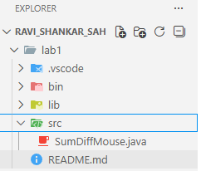
Source Code:
import java.awt.*;
import java.awt.event.*;

public class SumDiffMouse extends Frame implements MouseListener {

TextField t1, t2;
Label result;

SumDiffMouse() {
setLayout(new FlowLayout());

t1 = new TextField(10);
t2 = new TextField(10);
result = new Label("Result will be shown here");

add(new Label("Number 1:"));
add(t1);
add(new Label("Number 2:"));
add(t2);
add(result);

addMouseListener(this);

setTitle("Sum and Difference");
setSize(300, 200);
setVisible(true);
}

public void mousePressed(MouseEvent e) {
int a = Integer.parseInt(t1.getText());
int b = Integer.parseInt(t2.getText());
result.setText("Sum = " + (a + b));
}

public void mouseReleased(MouseEvent e) {
int a = Integer.parseInt(t1.getText());
int b = Integer.parseInt(t2.getText());
result.setText("Difference = " + (a - b));
}

public void mouseClicked(MouseEvent e) {}
public void mouseEntered(MouseEvent e) {}
public void mouseExited(MouseEvent e) {}

public static void main(String[] args) {
new SumDiffMouse();
}
}

Output:
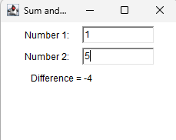
Conclusion:
The Java GUI program was implemented successfully using AWT components. It accepts two number through text fields as input. The program displays the sum on mouse press and the difference on mouse release. This application demonstrates the use of mouse event handling in Java.
Lab 2 : Write a Program using swing components to add two digit. Use text fields for inputs and output. Your program should display the result when the user presses a button.
Objective: To develop a Java GUI application using Swing components to add two numbers by accepting input through text fields and displaying the result on a button click.
File Explorer:
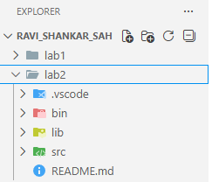
Source Code:
import javax.swing.*;
import java.awt.*;
import java.awt.event.*;

public class AddTwoNumbers extends JFrame implements ActionListener {

JTextField t1, t2, t3;
JButton b;
JLabel l1, l2, l3;

AddTwoNumbers() {

l1 = new JLabel("Number 1:");
l2 = new JLabel("Number 2:");
l3 = new JLabel("Result:");

t1 = new JTextField(10);
t2 = new JTextField(10);
t3 = new JTextField(10);
t3.setEditable(false);

b = new JButton("Add");

// Grid layout
setLayout(new GridLayout(4, 2, 10, 10));

add(l1); add(t1);
add(l2); add(t2);
add(l3); add(t3);
add(b);

// Button action
b.addActionListener(this);

setTitle("Addition Using Swing");
setSize(300, 200);
setVisible(true);

}

public void actionPerformed(ActionEvent e) {
int a = Integer.parseInt(t1.getText());
int b = Integer.parseInt(t2.getText());
t3.setText(String.valueOf(a + b));
}

public static void main(String[] args) {
new AddTwoNumbers();
}
}

Output:
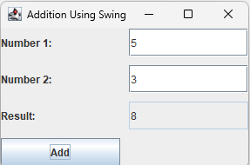
Conclusion:
The Java Swing program was successfully developed using labels, text fields, and a button. It accepts two numbers as input from the user and performs the addition operation when the button is pressed. The calculated result is displayed in the output text field. This program demonstrates the effective use of Swing components and event handling in Java GUI applications.

Lab 3: Write a program to Create a Form Below using Swing and perform Add, Subtract, Multiply and Divide as user click button with selected option.
Objective: To develop a Java Swing form that performs addition, subtraction, multiplication, and division based on the user’s selected option.
File Explorer:
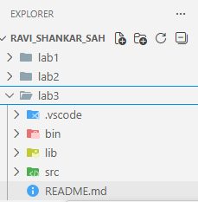
Source Code:
import javax.swing.*;
import java.awt.*;
import java.awt.event.*;

public class CalculatorForm extends JFrame implements ActionListener {

JTextField t1, t2, t3;
JRadioButton add, sub, mul, div;
JButton calc;
ButtonGroup bg;

CalculatorForm() {

JLabel l1 = new JLabel("Number 1:");
JLabel l2 = new JLabel("Number 2:");
JLabel l3 = new JLabel("Result:");

t1 = new JTextField(10);
t2 = new JTextField(10);
t3 = new JTextField(10);
t3.setEditable(false);

add = new JRadioButton("Add");
sub = new JRadioButton("Subtract");
mul = new JRadioButton("Multiply");
div = new JRadioButton("Divide");

bg = new ButtonGroup();
bg.add(add);
bg.add(sub);
bg.add(mul);
bg.add(div);

calc = new JButton("Calculate");
calc.addActionListener(this);

setLayout(new GridLayout(6, 2, 10, 10));

add(l1); add(t1);
add(l2); add(t2);
add(add); add(sub);
add(mul); add(div);
add(l3); add(t3);
add(new JLabel("")); add(calc);

setTitle("Swing Calculator");
setSize(350, 300);
setVisible(true);
setDefaultCloseOperation(JFrame.EXIT_ON_CLOSE);
}

public void actionPerformed(ActionEvent e) {

double a = Double.parseDouble(t1.getText());
double b = Double.parseDouble(t2.getText());
double result = 0;

if (add.isSelected())
result = a + b;
else if (sub.isSelected())
result = a - b;
else if (mul.isSelected())
result = a * b;
else if (div.isSelected())
result = a / b;

t3.setText(String.valueOf(result));
}

public static void main(String[] args) {
new CalculatorForm();
}
}

Output:
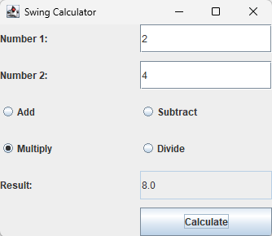
Conclusion:
The Java Swing calculator form was successfully implemented using text fields, radio buttons, and a button. The program allows the user to select an arithmetic operation and performs the calculation when the button is clicked. The result is displayed in the output text field. This application demonstrates effective use of Swing components and event handling.

Lab 4: Write a GUI program using components to find sum and difference of two numbers.Use two text fields for giving input and a label for output. The program should display sum if user presses mouse and difference if user release mouse using adapter class.
Objective: To develop a Java AWT GUI application that calculates the sum and difference of two numbers using mouse press and release events with the help of an adapter class.
File Explorer:
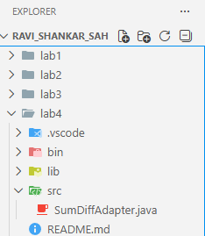
Source Code:
import java.awt.*;
import java.awt.event.*;

public class SumDiffAdapter extends Frame {

TextField t1, t2;
Label result;

SumDiffAdapter() {

Label l1 = new Label("Number 1:");
Label l2 = new Label("Number 2:");
result = new Label("Result will be shown here");

t1 = new TextField(10);
t2 = new TextField(10);

setLayout(new GridLayout(3, 2, 10, 10));

add(l1); add(t1);
add(l2); add(t2);
add(new Label("")); add(result);

addMouseListener(new MouseAdapter() {

public void mousePressed(MouseEvent e) {
int a = Integer.parseInt(t1.getText());
int b = Integer.parseInt(t2.getText());
result.setText("Sum = " + (a + b));
}

public void mouseReleased(MouseEvent e) {
int a = Integer.parseInt(t1.getText());
int b = Integer.parseInt(t2.getText());
result.setText("Difference = " + (a - b));
}
});

setTitle("Sum and Difference using Adapter");
setSize(350, 200);
setVisible(true);
}

public static void main(String[] args) {
new SumDiffAdapter();
}
}

Output:
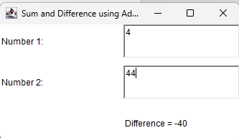
Conclusion:
The Java GUI program was successfully implemented using AWT components and the MouseAdapter class. It accepts two numbers through text fields and displays the sum when the mouse is pressed and the difference when the mouse is released. This program demonstrates the use of adapter classes to handle mouse events efficiently in Java.

Lab 5: Create a Simple Login Form using GridLayout in Java.
Objective: To create a simple login form using Java Swing by creating objects of components and arranging them using GridLayout.
File Explorer:
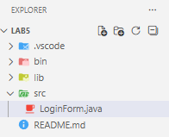
Source Code:
import javax.swing.*;
import java.awt.*;

public class LoginForm extends JFrame {

JLabel l1, l2;
JTextField t1;
JPasswordField t2;
JButton b1;

LoginForm() {

l1 = new JLabel("Username:");
l2 = new JLabel("Password:");

t1 = new JTextField(15);
t2 = new JPasswordField(15);

b1 = new JButton("Login");

setLayout(new GridLayout(3, 2, 10, 10));

add(l1); add(t1);
add(l2); add(t2);
add(new JLabel("")); add(b1);

setTitle("Login Form");
setSize(300, 150);
setVisible(true);
}

public static void main(String[] args) {
new LoginForm();
}
}

Output:
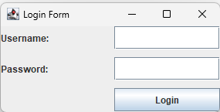
Conclusion:
The login form was successfully created using Swing components such as labels, text fields, and a button. All components were instantiated as objects and arranged using GridLayout. This program demonstrates basic GUI design in Java without using event handling.

Lab 6: Create a Simple Login Form using GridBagLayout in Java.
Objective: To design a simple login form using Java Swing components arranged with the GridBagLayout manager.
File Explorer:
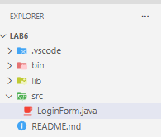
Source Code:
import javax.swing.*;
import java.awt.*;

public class LoginForm extends JFrame {

JLabel l1, l2;
JTextField t1;
JPasswordField t2;
JButton b1;

LoginForm() {

l1 = new JLabel("Username:");
l2 = new JLabel("Password:");

t1 = new JTextField(15);
t2 = new JPasswordField(15);

b1 = new JButton("Login");

setLayout(new GridBagLayout());
GridBagConstraints gbc = new GridBagConstraints();

gbc.insets = new Insets(5, 5, 5, 5);

gbc.gridx = 0; gbc.gridy = 0;
add(l1, gbc);

gbc.gridx = 1; gbc.gridy = 0;
add(t1, gbc);

gbc.gridx = 0; gbc.gridy = 1;
add(l2, gbc);

gbc.gridx = 1; gbc.gridy = 1;
add(t2, gbc);

gbc.gridx = 1; gbc.gridy = 2;
add(b1, gbc);

setTitle("Login Form");
setSize(350, 200);
setVisible(true);
}

public static void main(String[] args) {
new LoginForm();
}
}

Output:
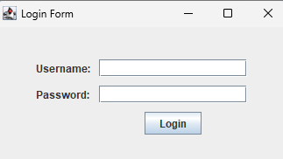
Conclusion:
The login form was successfully created using Swing components and GridBagLayout. Labels, text fields, a password field, and a button were positioned precisely using grid constraints. This program demonstrates flexible and structured GUI design in Java without event handling.

Lab 7: Write a program that divides the frame into five regions by using border layout and then add panels in the east, north and center region. Finally add some descriptive label in the north panel, buttons with icon in the east panel and a sample form in the center panel. You can further subdivide the center panel, if necessary. Prepare a program with three text boxes First Number, Second Number, and Result and four buttons add, subtract, multiply and divide. Handle the events to perform the required operation and display results.

Objective: The objective of this experiment is to design a Java GUI using BorderLayout and panels. It also aims to create a simple calculator using text fields and buttons with event handling.
File Explorer:
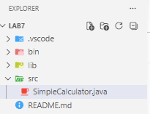
Source Code:
import javax.swing.*;
import java.awt.*;
import java.awt.event.*;

public class SimpleCalculator extends JFrame implements ActionListener {

JTextField t1, t2, t3;
JButton add, sub, mul, div;

SimpleCalculator() {

setTitle("Calculator");
setSize(400, 250);
setLayout(new BorderLayout());

// NORTH (Label)
JLabel label = new JLabel("Simple Calculator", JLabel.CENTER);
add(label, BorderLayout.NORTH);

// CENTER (Form only)
JPanel center = new JPanel(new GridLayout(3, 2, 5, 5));

center.add(new JLabel("First Number"));
t1 = new JTextField();
center.add(t1);

center.add(new JLabel("Second Number"));
t2 = new JTextField();
center.add(t2);

center.add(new JLabel("Result"));
t3 = new JTextField();
t3.setEditable(false);
center.add(t3);

add(center, BorderLayout.CENTER);

// EAST (Operation Buttons)
JPanel east = new JPanel(new GridLayout(4, 1, 5, 5));

add = new JButton("Add");
sub = new JButton("Sub");
mul = new JButton("Mul");
div = new JButton("Div");

east.add(add);
east.add(sub);
east.add(mul);
east.add(div);

add(east, BorderLayout.EAST);

// Events
add.addActionListener(this);
sub.addActionListener(this);
mul.addActionListener(this);
div.addActionListener(this);

setDefaultCloseOperation(JFrame.EXIT_ON_CLOSE);
setVisible(true);
}

public void actionPerformed(ActionEvent e) {
double a = Double.parseDouble(t1.getText());
double b = Double.parseDouble(t2.getText());
double r = 0;

if (e.getSource() == add)
r = a + b;
if (e.getSource() == sub)
r = a - b;
if (e.getSource() == mul)
r = a * b;
if (e.getSource() == div)
r = a / b;

t3.setText("" + r);
}

public static void main(String[] args) {
new SimpleCalculator();
}
}

Output:
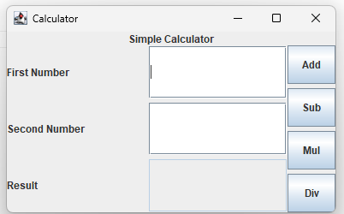
Conclusion:
The program was implemented successfully using BorderLayout and multiple panels. The calculator performed arithmetic operations correctly based on user input. Event handling helped in executing button actions efficiently. Thus, the experiment improved understanding of GUI design and event-driven programming.
Lab 8: Design a form with three buttons with captions “RED,” “BLUE,” and “GREEN,” respectively. Then write a program to handle the event such that when the user clicks the button, the color of that button will be the same as its caption.
Objective: The objective of this experiment is to design a form with buttons and handle events. It aims to change button and background colors based on user interaction.
File Explorer:
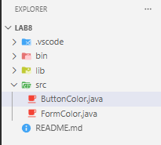
Source Code:
import javax.swing.*;
import java.awt.*;
import java.awt.event.*;

public class ButtonColor implements ActionListener {

JButton red, blue, green;

ButtonColor() {
JFrame f = new JFrame("Button Color");

red = new JButton("RED");
blue = new JButton("BLUE");
green = new JButton("GREEN");

f.setLayout(new FlowLayout());

f.add(red);
f.add(blue);
f.add(green);

red.addActionListener(this);
blue.addActionListener(this);
green.addActionListener(this);

f.setSize(300,200);
f.setDefaultCloseOperation(JFrame.EXIT_ON_CLOSE);
f.setVisible(true);
}

public void actionPerformed(ActionEvent e) {
if(e.getSource() == red)
red.setBackground(Color.RED);

if(e.getSource() == blue)
blue.setBackground(Color.BLUE);

if(e.getSource() == green)
green.setBackground(Color.GREEN);
}

public static void main(String[] args) {
new ButtonColor();
}
}

Output:
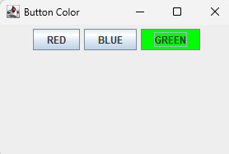
Design a form with three buttons with captions “RED,” “BLUE,” and “GREEN,” respectively. Then write a program to handle the event such that when the user clicks the button, the color of Form background will be the same as its caption.

import javax.swing.*;
import java.awt.*;
import java.awt.event.*;

public class FormColor implements ActionListener {

JFrame f;
JButton red, blue, green;

FormColor() {
f = new JFrame("Form Color");

red = new JButton("RED");
blue = new JButton("BLUE");
green = new JButton("GREEN");

f.setLayout(new FlowLayout());

f.add(red);
f.add(blue);
f.add(green);

red.addActionListener(this);
blue.addActionListener(this);
green.addActionListener(this);

f.setSize(300,200);
f.setDefaultCloseOperation(JFrame.EXIT_ON_CLOSE);
f.setVisible(true);
}

public void actionPerformed(ActionEvent e) {
if(e.getSource() == red)
f.getContentPane().setBackground(Color.RED);

if(e.getSource() == blue)
f.getContentPane().setBackground(Color.BLUE);

if(e.getSource() == green)
f.getContentPane().setBackground(Color.GREEN);
}

public static void main(String[] args) {
new FormColor();
}
}

Output:
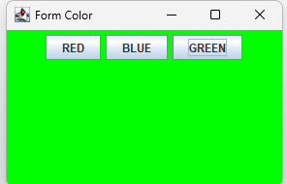
Conclusion:
The program successfully changed the color of buttons and form background on click. Event handling was used to detect user actions effectively. The output matched the expected behavior. This experiment enhanced knowledge of GUI interaction and color handling.

Lab 9: rite a Java program using Swing that demonstrates the use of different layout managers (FlowLayout, GridLayout, and BorderLayout).
- Divide the main frame into three panels using BorderLayout:
  - North Panel: Use FlowLayout to arrange three labels (Name, Roll No, Class) in a single row.
  - Center Panel: Use GridLayout (3x2) to create a simple login form with two text fields (Username, Password), a JCheckBox (“Remember Me”), and a JButton (“Login”).
  - South Panel: Use FlowLayout to add two buttons (Reset and Exit).
- Handle events so that:
  - When Login is pressed, display the entered username in a message dialog.
  - When Reset is pressed, clear the text fields.
When Exit is pressed, close the program.

Objective: The objective of this experiment is to demonstrate the use of different layout managers in Java Swing. It also aims to design a structured form and handle button events.
File Explorer:
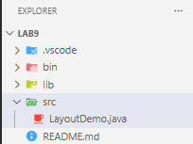
Source Code:
import javax.swing.*;
import java.awt.*;
import java.awt.event.*;

public class LayoutDemo extends JFrame implements ActionListener {

JTextField usernameField;
JPasswordField passwordField;
JCheckBox rememberCheck;
JButton loginBtn, resetBtn, exitBtn;

LayoutDemo() {
setTitle("Layout Manager Demo");
setSize(400, 250);
setLayout(new BorderLayout(10,10));

JPanel northPanel = new JPanel(new FlowLayout(FlowLayout.CENTER, 10, 10));
northPanel.add(new JLabel("Name"));
northPanel.add(new JLabel("Roll No"));
northPanel.add(new JLabel("Class"));
add(northPanel, BorderLayout.NORTH);

JPanel centerPanel = new JPanel(new GridLayout(3, 2, 5, 5));
centerPanel.add(new JLabel("Username:"));
usernameField = new JTextField();
centerPanel.add(usernameField);
centerPanel.add(new JLabel("Password:"));
passwordField = new JPasswordField();
centerPanel.add(passwordField);
rememberCheck = new JCheckBox("Remember Me");
centerPanel.add(rememberCheck);
loginBtn = new JButton("Login");
centerPanel.add(loginBtn);
add(centerPanel, BorderLayout.CENTER);

JPanel southPanel = new JPanel(new FlowLayout());
resetBtn = new JButton("Reset");
exitBtn = new JButton("Exit");
southPanel.add(resetBtn);
southPanel.add(exitBtn);
add(southPanel, BorderLayout.SOUTH);

loginBtn.addActionListener(this);
resetBtn.addActionListener(this);
exitBtn.addActionListener(this);

setDefaultCloseOperation(JFrame.EXIT_ON_CLOSE);
setVisible(true);
}

public void actionPerformed(ActionEvent e) {
if(e.getSource() == loginBtn) {
String username = usernameField.getText();
JOptionPane.showMessageDialog(this, "Username entered: " + username);
} else if(e.getSource() == resetBtn) {
usernameField.setText("");
passwordField.setText("");
rememberCheck.setSelected(false);
} else if(e.getSource() == exitBtn) {
System.exit(0);
}
}

public static void main(String[] args) {
new LayoutDemo();
}
}

Output:
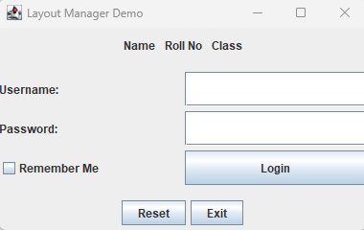
Conclusion:
The program successfully demonstrated FlowLayout, GridLayout, and BorderLayout. The login form and buttons worked correctly with proper event handling. User inputs were processed and displayed as required. This experiment helped in understanding layout management and GUI structuring.

Lab 10: Design a form with three buttons with captions “Circle,” “Square,” and “Triangle.”
- When the user clicks the “Circle” button, draw a red circle in the center of the frame.
- When the user clicks the “Square” button, draw a blue square in the center of the frame.
- When the user clicks the “Triangle” button, draw a green triangle in the center of the frame.
Objective:
The objective of this experiment is to design a GUI that draws shapes based on user input. It also aims to use graphics for drawing different shapes.
File Explorer:
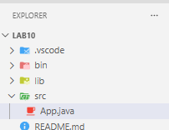
Source Code:
import javax.swing.*;
import java.awt.*;
import java.awt.event.*;
public class App extends Canvas implements ActionListener {
private String shape = ""; // which shape to draw
private JFrame f;

public App() {
f = new JFrame("Shape Drawer");
f.setSize(400, 400);
f.setDefaultCloseOperation(JFrame.EXIT_ON_CLOSE);
f.setLayout(new BorderLayout());

// Create buttons
JButton circleBtn = new JButton("Circle");
JButton rectBtn = new JButton("Rectangle");
JButton squareBtn = new JButton("Square");

// Add action listeners
circleBtn.addActionListener(this);
rectBtn.addActionListener(this);
squareBtn.addActionListener(this);

// Panel to hold buttons
JPanel panel = new JPanel();
panel.add(circleBtn);
panel.add(rectBtn);
panel.add(squareBtn);

f.add(panel, BorderLayout.NORTH);

// Add canvas (this) to center
f.add(this, BorderLayout.CENTER);

f.setVisible(true);
}

@Override
public void paint(Graphics g) {
if (shape.equals("Circle")) {
g.setColor(Color.YELLOW);
g.fillOval(100, 80, 150, 150);
g.setColor(Color.RED);
g.drawOval(100, 80, 150, 150);
}
else if (shape.equals("Rectangle")) {
g.setColor(Color.CYAN);
g.fillRect(80, 100, 200, 120);
g.setColor(Color.BLUE);
g.drawRect(80, 100, 200, 120);
}
else if (shape.equals("Square")) {
g.setColor(Color.PINK);
g.fillRect(100, 80, 150, 150);
g.setColor(Color.MAGENTA);
g.drawRect(100, 80, 150, 150);
}
}

@Override
public void actionPerformed(ActionEvent e) {
shape = e.getActionCommand(); // Circle / Rectangle / Square
repaint(); // redraw with new shape
}

public static void main(String[] args) {
new App(); // create object to launch GUI
}
}

Output:
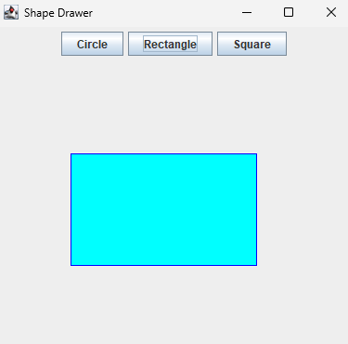
Conclusion:
The program successfully displayed shapes like circle, square, and triangle. Each button triggered the correct shape with the specified color. Graphics methods were used effectively for drawing. This experiment improved understanding of drawing in Java Swing.

Lab 11: Design a Swing application that contains three radio buttons labeled "Red", "Green", and "Blue". When the user selects a radio button, the background color of the window should change to the selected color. Implement event handling using an ItemListener.
Objective: The objective of this experiment is to use radio buttons and ItemListener in Java Swing. It aims to change the background color based on selection.

File Explorer:
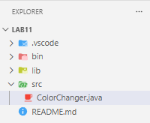
Source Code:
import javax.swing.*;
import java.awt.*;
import java.awt.event.*;

public class ColorChanger extends JFrame implements ItemListener {

JRadioButton redBtn, greenBtn, blueBtn;
ButtonGroup group;

ColorChanger() {
setTitle("Color Changer");
setSize(300, 200);
setLayout(new FlowLayout());

redBtn = new JRadioButton("Red");
greenBtn = new JRadioButton("Green");
blueBtn = new JRadioButton("Blue");

group = new ButtonGroup();
group.add(redBtn);
group.add(greenBtn);
group.add(blueBtn);

add(redBtn);
add(greenBtn);
add(blueBtn);

redBtn.addItemListener(this);
greenBtn.addItemListener(this);
blueBtn.addItemListener(this);

setDefaultCloseOperation(JFrame.EXIT_ON_CLOSE);
setVisible(true);
}

public void itemStateChanged(ItemEvent e) {
if (redBtn.isSelected())
getContentPane().setBackground(Color.RED);
else if (greenBtn.isSelected())
getContentPane().setBackground(Color.GREEN);
else if (blueBtn.isSelected())
getContentPane().setBackground(Color.BLUE);
}

public static void main(String[] args) {
new ColorChanger();
}
}

Output:
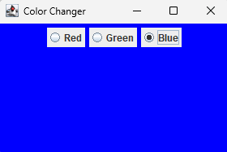
Conclusion:
The program correctly changed the background color when a radio button was selected. ItemListener handled the selection events effectively. The interface responded as expected. This experiment enhanced knowledge of event handling with radio buttons.

Lab 12: Write a Java Swing program to create a toolbar with three buttons. Each button should display an icon (New, Login, and Logout). Place the toolbar at the top of the window using a suitable layout. When a button is clicked, display a message dialog showing the name of the action (e.g., “New File Created”, “Login Successful”, “Logged Out”).
Objective: The objective of this experiment is to create a toolbar with buttons and icons in Java Swing. It also aims to handle button click events.
File Explorer:
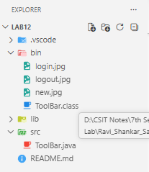
Source Code:
import javax.swing.*;
import java.awt.*;
import java.awt.event.*;

public class ToolBar extends JFrame implements ActionListener {

JButton newBtn, loginBtn, logoutBtn;

ToolBar() {
setTitle("Toolbar Demo");
setSize(400, 200);
setLayout(new BorderLayout());

JToolBar toolbar = new JToolBar();

newBtn = new JButton(new ImageIcon("new.jpg"));
newBtn.setToolTipText("New");
loginBtn = new JButton(new ImageIcon("login.jpg"));
loginBtn.setToolTipText("Login");
logoutBtn = new JButton(new ImageIcon("logout.jpg"));
logoutBtn.setToolTipText("Logout");

toolbar.add(newBtn);
toolbar.add(loginBtn);
toolbar.add(logoutBtn);

add(toolbar, BorderLayout.NORTH);

newBtn.addActionListener(this);
loginBtn.addActionListener(this);
logoutBtn.addActionListener(this);

setDefaultCloseOperation(JFrame.EXIT_ON_CLOSE);
setVisible(true);
}

public void actionPerformed(ActionEvent e) {
if(e.getSource() == newBtn)
JOptionPane.showMessageDialog(this, "New File Created");
else if(e.getSource() == loginBtn)
JOptionPane.showMessageDialog(this, "Login Successful");
else if(e.getSource() == logoutBtn)
JOptionPane.showMessageDialog(this, "Logged Out");
}

public static void main(String[] args) {
new ToolBar();
}
}

Output:
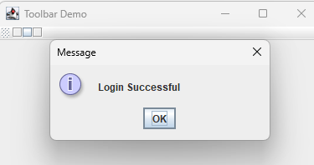
Conclusion:
The toolbar was created successfully with functional buttons. Each button displayed the correct message when clicked. Event handling was implemented properly. This experiment improved understanding of toolbars and GUI components.

Lab 13: Write a java program to inset 5 student records and display record in name ascending order, given table student(Id,Name,Gender,Address) using JDBC.

Objective: The objective of this experiment is to insert student records into a database using JDBC. It also aims to retrieve and display records in ascending order.
File Explorer:
Source Code:
Output:
Conclusion:
The program successfully inserted and retrieved student records. Sorting was applied correctly based on names. JDBC connectivity worked properly. This experiment enhanced database handling skills in Java.

Lab 14: Write a java program update salary by 15% wholes salary less than 20000 from given table student(Id,Name,Salary,Gender) using JDBC

Objective: The objective of this experiment is to update salary records in a database using JDBC. It aims to apply conditional updates based on salary criteria.
File Explorer:
Source Code:
Output:
Conclusion:
The program successfully updated salaries below the specified limit. Database operations were executed correctly. The update condition worked as expected. This experiment improved understanding of SQL update queries in Java.

Lab 15: Write a Java program using JDBC to connect to a MySQL database, create a table named tblStudent with columns id, name, and email, and insert a record into the table using a prepared statement.
Objective: The objective of this experiment is to connect Java with MySQL using JDBC. It also aims to create a table and insert records using prepared statements.
File Explorer:
Source Code:
Output:
Conclusion:
The program successfully connected to the database and created the table. Data was inserted securely using prepared statements. The operations were executed without errors. This experiment strengthened knowledge of JDBC and database creation.

Lab 16: Write a Java program using JDBC to connect to a MySQL database and display employee details from the emp table. The program should demonstrate how to move through the result set using navigation methods such as first(), last(), previous(), and next(), and print the corresponding employee records on the console.

Objective: The objective of this experiment is to demonstrate navigation through ResultSet in JDBC. It aims to use methods like first(), last(), next(), and previous().
File Explorer:
Source Code:
Output:
Conclusion:
The program successfully navigated through database records. All navigation methods worked correctly and displayed proper results. The concept of ResultSet traversal was clearly understood. This experiment improved database interaction skills.

Lab 17: Write a Java program using JDBC to connect to a MySQL database and retrieve an employee record from the emp table based on a given ID using a prepared statement. The program should use an updatable ResultSet to modify the employee’s name and update the record in the database.

Objective: The objective of this experiment is to retrieve and update database records using JDBC. It also aims to use prepared statements and updatable ResultSet.
File Explorer:
Source Code:
Output:
Conclusion:
The program successfully retrieved and updated employee records. Changes were applied correctly using ResultSet methods. Prepared statements ensured secure execution. This experiment enhanced understanding of dynamic database updates.

Lab 18: Write a program to demonstrate servlet life cycle.
Objective: The objective of this experiment is to understand the life cycle of a servlet. It aims to demonstrate methods like init(), service(), and destroy().
File Explorer:
Source Code:
Output:
Conclusion:
The servlet lifecycle methods were executed in proper sequence. Each phase was clearly demonstrated and understood. The program worked as expected in a web environment. This experiment improved knowledge of servlet processing.

Lab 19: Write a Java program to store “Samriddhi College” String value in session and retrieve from session using Servlet.
Objective: The objective of this experiment is to store and retrieve data using session in servlet. It aims to maintain user data across requests
File Explorer:
Source Code:
Output:
Conclusion:
The program successfully stored and retrieved session data. The session mechanism worked properly across multiple requests. Data persistence was achieved effectively. This experiment improved understanding of session management.
Lab 20: Write a Java program to store Username and Password from two input field in cookies and retrieve value from cookies using Servlet.
Objective: The objective of this experiment is to store and retrieve user data using cookies in servlet. It aims to understand client-side data storage.
File Explorer:
Source Code:
Output:
Conclusion:
The program successfully stored and retrieved cookie values. User data was maintained correctly between requests. Cookie handling was implemented properly. This experiment enhanced knowledge of client-side storage.
Lab 21: Write a Java program to store Username and Password from two input field in cookies and retrieve value from cookies using JSP.
Objective: The objective of this experiment is to use cookies in JSP for storing user data. It aims to retrieve and display cookie values.
File Explorer:
Source Code:
Output:
Conclusion:
The JSP program successfully handled cookies. Data was stored and retrieved correctly. The output matched the expected result. This experiment improved JSP and cookie handling skills.

Lab 22: Write a program to a JSP web form to take input of a student and submit it to second JSP file which may simply print the values of form submission.
Objective: The objective of this experiment is to create a JSP form and pass data between pages. It aims to display submitted values in another JSP file.
File Explorer:
Source Code:
Output:
Conclusion:
The form data was successfully transferred between JSP pages. Input values were displayed correctly. The program worked as expected. This experiment enhanced understanding of JSP form handling.
Lab 23: Write a program to a JSP web form to take principle,Time and Rate as input from textfield and calculate it and display Simple interest in second JSP.
Objective: The objective of this experiment is to calculate simple interest using JSP. It aims to take input and display calculated results.
File Explorer:
Source Code:
Output:
Conclusion:
The program correctly calculated and displayed simple interest. Input values were processed accurately. The result matched expected calculations. This experiment improved understanding of JSP-based computation.
Lab 24: Write a java program to add two digit using RMI
Objective: The objective of this experiment is to implement Remote Method Invocation (RMI) in Java. It aims to perform addition of numbers remotely.
File Explorer:
Source Code:
Output:
Conclusion:
The RMI program was successfully executed between client and server. Remote method calls worked correctly. The addition result was accurate. This experiment enhanced understanding of distributed computing in Java.

